https://www.nytimes.com/2014/08/05/nyregion/steve-post-sardonic-wit-on-wnyc-is-dead-at-70.html?ref=oembed

Steve Post, Sardonic Wit on WNYC, Is Dead at 70

By Douglas Martin

The Kew York Times

Aug. 5, 2014

• 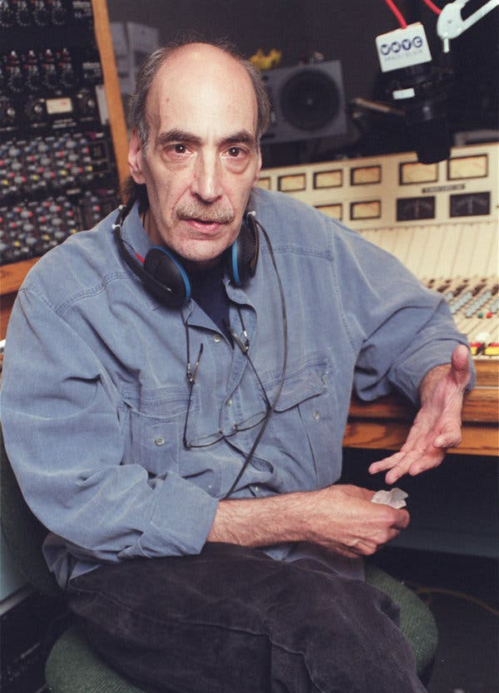

Steve Post at WNYC in 2002.Credit...Carol Halebian

Steve Post, a curmudgeonly New York City public radio personality who mischievously mocked himself, his employers, his sponsors and the conventions of broadcasting — he called weather reports “weather lies” — died on Sunday in the two-room apartment on Manhattan’s Upper West Side where he lived for 30 years. He was 70.

His friend Larry Josephson, another longtime public radio host, said the cause was lung cancer.

Mr. Post was host of “Morning Music With Steve Post,” which was broadcast on WNYC from 9 a.m. to noon from 1982 to 2001. The show featured classical music, which he was “proud to know nothing about,” he told The Star-Ledger of Newark in 1997.

But he had a rich play list and usually managed to pronounce composers’ names properly, Mr. Josephson said in his defense, adding that “he always threw in a lot of wonderful stuff in between.”

He prided himself on presenting what he called “the world’s most biased newscast.” After Mayor Edward I. Koch had a stroke and doctors said he had “the brain of a 12-year-old” at the time, Mr. Post referred to the mayor as “him with the 12-year-old brain.”

After 2002, he was the host of “The No Show,” a quirky cocktail of music and commentary named for his famously contrarian opinions. He once suggested constructing orphanages adjacent to penitentiaries to save on transport expenses.

He began his broadcasting career in 1965 at WBAI-FM, a listener-supported countercultural nerve center where comedy mixed with Jimi Hendrix, Mozart and political protest. During his 14 years there, he organized a “Fat-In” at Central Park to celebrate the overweight.

“Steve is the closest thing we have to Lenny Bruce,” Mr. Josephson said in an interview with The New York Times in 2002. “Public radio is safe, bland and boring, and he isn’t.”

Mr. Post, who had a bristling mustache and an intense stare, delighted in satirizing sacred cows — including public radio’s pledge drives. “If we don’t reach our fund-raising goal I’m going to have to set fire to your houses,” he once growled.

During a 1990 pledge drive, he had Mary Perot Nichols, president of WNYC, read a statement at the beginning of the show, announcing, “Effective immediately, Mr. Post has been terminated” for crimes that included allegations of “financial and military ties” with “various fascist dictators.”

Then Ms. Nichols suggested that listeners could win Mr. Post’s reinstatement by pledging $40 and becoming members. They did, in record numbers.

After mentioning a hospital as a station underwriter, he asked why hospitals had to advertise for sick people — “weren’t there enough of them?” he wondered — and signaled his displeasure by rushing through the text at breakneck speed.

Mr. Post was modest about himself. “I am not a well-read or a well-educated person,” he told The Times. “But I have a deep voice, which makes me sound authoritative.”

In 1997, Peter Goodman, a radio reporter for Newsday, said it was exactly this unpretentiousness that made people respond to Mr. Post. “In a radio age when personality means rant, hysteria, terminal adolescence and unrelieved, unbelievable perkiness,” Mr. Goodman wrote, “Post is a person. He’s depressed. He kvetches. He whines.”

Steven Allen Post was born in the Bronx on March 20, 1944. He remembered playing with a tape recorder at age 8 pretending to be a disc jockey. After his mother died of colon cancer when he was 10, he was sent to a boarding school in New Jersey. His first jobs included doing office work for an antiwar organization and two advertising agencies.

By his account, when he applied for a job editing the program guide for WBAI, the managers there thought for some reason he was seeking work as a bookkeeper and hired him as one. He “got away” with being a bookkeeper for nine months, he wrote in his 1974 memoir, “Playing in the FM Band: A Personal Account of Free Radio.”

With his resonant voice, he was subsequently made a staff announcer, a job he had always wanted. His first assignment was to substitute for Bob Fass, who pioneered free-form radio with a WBAI show. At 4 a.m., Mr. Post grandly invited musical requests under the assumption that no one was listening.

“The entire switchboard lit up at once,” he told The Times. “I had a vision of standing naked in Carnegie Hall.” Terrified, he blurted, “Thank you all for listening,” and signed off.

He was briefly WBAI’s station manager, a job he hated; the director of radio at C. W. Post College, a campus of Long Island University; and a news reader for WBLS-FM, a black-music-format station.

Mr. Post is survived by his wife of 38 years, Laura Rosenberg, and his brother, Gerry.

He rejected notions that his views represented 1960s idealism, however much he admired those values. In a 1989 interview with Newsday, he called himself “a Hobbesian, not a Marxist.” He continued, “I believe people are essentially brutal, murderous, lying bastards who put on masks of civility to make society work.”

Or, as he later said on the air, “Just when you think you’ve scraped the bottom, you find you’re only scratching the surface.”

A correction was made on Aug. 7, 2014

An obituary on Tuesday about the New York radio personality Steve Post misstated the duration of his marriage to Laura Rosenberg. They were married for 38 years, not 47. The obituary also referred imprecisely to C. W. Post College, where Mr. Post was briefly the director of radio. It has always been a campus of Long Island University; it is not just “now” a campus of the university.

