The Art of Destroying an Artwork

By David Xu Borgonjon

The New York Times

October 25, 2017

Under pressure from online petitions and on-site protests, the Guggenheim Museum last month withdrew or modified three works of art that involved animals from its survey of Chinese contemporary art, called “Art and China After 1989: Theater of the World.” The titular work in the show, a sculptural vitrine, was originally filled with live insects and reptiles, which the museum removed.

The decision came after intense protests, but it also set off its own debate. Critics called it censorship, and worried that advocacy groups — in this case, animal rights organizations — now had veto power over art and its public display.

But there’s a problem with this binary formulation, which opposes the sacrosanct art object to the interests and demands of the public. Curators need to think about more creative ways to withdraw art from public display. Rather than thinking of calls to remove art as either right or wrong, institutions should think of them as creative opportunities to reimagine who their public is.

This spring, a painting of Emmett Till by a white artist, Dana Schutz, in the Whitney Biennial prompted complaints and protest performances calling for its removal, and in some cases destruction. The Whitney Museum instead organized a panel and issued copious clarifying statements. In the wake of the Guggenheim decision, critics have contrasted the two museums’ responses; as the artist Pastiche Lumumba wrote on Facebook, the Guggenheim “responded to words with action, and that didn’t happen at the Whitney Museum.”

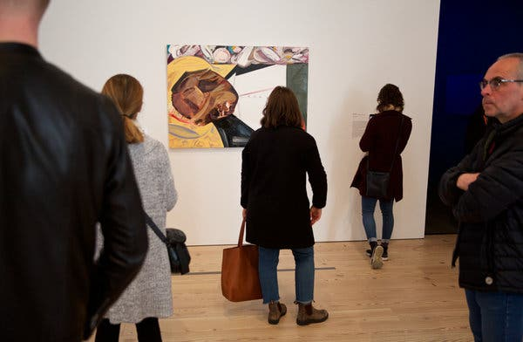

A painting of Emmett Till in the Whitney Biennial, in March.

But in some ways, even though the two institutions’ responses were different, they also had more in common than you’d think. The Guggenheim acquiesced, positioning itself along the way as a victim of censorship; the Whitney refused, and sought to soften this refusal with programs and texts. In both cases, the museums reinforced a debate about an artwork that only makes room for one question: Should it stay or should it go?

What we should be asking, instead, is how it should “go.” A work of art could be destroyed (burned, buried, shredded), edited, documented, mourned or even substituted. It could be supplemented with performances, talks, protests. It could be turned into minimalist furniture for the museum cafe, or sold on eBay, with the proceeds going to charity.

Contemporary art theory has long held that the artwork takes place not in the moment of creation or exhibition, but rather in the ways that it circulates in the world. That’s why withdrawal isn’t just a negative act. The museum is actively putting the withdrawal into the world, which will then circulate beside and on top of the artwork, as a rumor, a footnote, a filter. I am arguing for a creative acceptance of the pressure to withdraw an artwork, rather than either outright rejection or reluctant acquiescence.

For a different example, look to the Walker Art Center in Minneapolis. In the spring the museum erected an outdoor sculpture by the artist Sam Durant that replicated the gallows where 38 Dakota people were executed in 1862.

After an outcry that the work appeared to be a monument to a massacre, the museum convened a mediation session that included the artist, parks officials, museum staff members and, most important, Dakota elders. They decided to destroy the work by burying it, ceding any materials and intellectual property to the Dakota along the way.

Was that “censorship”? The work was removed, but in a creative way that arguably added more meaning to the work than it ever would have had it remained standing.

In some ways, the emptying out of “Theater of the World” also made it more meaningful. Huang Yong Ping, the Paris-based Chinese provocateur behind that work, has frequently been censored. His work “Bat Project II,” a reproduction of part of an American spy plane that crashed into a Chinese fighter, was withdrawn from the 2002 Guangzhou Triennial. The depression that the artwork left in the ground remained, however, as a haunting trace of the original work. Whether intentional or not, this sort of lasting reminder of a work should be an inspiration for how museums can handle controversial works: removal, but not erasure.

For another example, look to how artists responded to the Whitney Biennial. Parker Bright occupied the space in front of the Till painting on several days with text written across his shirt: “No lynch mob” and “Black death spectacle.” His intervention confronted viewers with the reality of a physical body, not just an abstraction of one.

A banner that Pastiche Lumumba hung from the High Line, which runs alongside the Whitney, drew attention to the way that history is not yet past: “The white woman whose lies got Emmett Till lynched is still alive in 2017. Feel old yet?” For observers like myself, this performance was more compelling than the original painting.

Social media has changed how we communicate, and social inequity continues to differentiate how we feel. These dynamics are changing the way we curate. For one thing, the work of exhibition-making no longer ends when the show opens. Instead, it continues as a process of listening, a public performance that goes on for months.

In some way, as curator Hera Chan points out, the dynamics of the platform economy threaten to make curatorial expertise obsolete. Who needs us when institutions can figure out, thanks to social media, crowdsourcing and machine learning, audience preferences quickly and accurately? The difficult question of who “we” are, when we are faced with a controversial artwork, is the curator’s only remaining raison d’être. Consider that exhibitions don’t have a standard rating system, like movies or music — at some level, we must believe that every show should be accessible to all of us. Like churches or public television in a different age, museums are now our civic institutions, where we go to argue about who counts as “us.”

The “should it stay or should it go” approach fumbles the opportunity to broaden and enrich what that “us” is. It’s a difficult question, and we will not agree, but even asking it together creates a kind of community. It falls to curators to facilitate this conversation. Institutions, following the lead of artists, should respond creatively to the call for censorship. Perhaps the withdrawal of the artwork can make room for something else to come into view: a new public.

David Xu Borgonjon is a curator and writer.

