No More Manholes in Berkeley as City Writes Gender Out of Codes

By Thomas Fuller and Nicholas Bogel-Burroughs

The New York Times

July 19, 2019

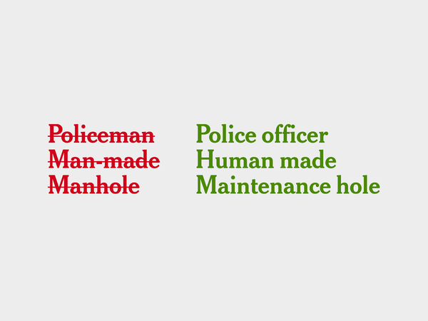

BERKELEY, Calif. — The city of Berkeley, long a bastion of liberal ideas, voted this week to purge gender from its law books.

Manhole will be replaced with maintenance hole. Sisters and brothers will be replaced with siblings. And he or she will be banished in favor of they, even if referring to one person.

The City Council’s unanimous decision was meant to send a message about equal chances and representation, said Councilmember Lori Droste.

“Your gender has no relevance in whether you can perform work and receive services,” Ms. Droste said. “Women and nonbinary folks are just as entitled to accurate representation.”

The law would apply to traffic, health and safety regulations, garbage collection, environmental rules, construction permits — all of the business of a city.

What happens in California has often made its way across the country, whether it was banning smoking in restaurants, enacting strict tailpipe emission standards or allowing right turns at red lights.

But are other American cities ready as well to fundamentally change the English language?

Keith Johnson, the chair of the department of linguistics at the University of California, Berkeley — up the road from Berkeley City Hall — says the English language has been evolving away from gender-specific terms for many years. Stewardess is out of touch; the preferred term is of course flight attendant. Waitresses and waiters are now often known as servers.

“As the society changes there will be pressure for the language to change as well,” Professor Johnson said. “That will be a generational change.”

Already, a number of cities in recent years have adopted laws on gender-related speech.

Philadelphia residents approved a ballot measure by about two-thirds support in May that changed the city’s charter to describe representatives as “council members” rather than “councilmen.” The borough of Fairbanks North Star in Alaska unanimously passed a resolution in late February removing gendered words from its city code and replacing some with the singular “they,” “their” and “them.”

Last month, Multnomah County in Oregon, which has a population of about 800,000 and includes Portland, passed a similar measure, replacing gendered pronouns with the singular use of “they” and related words. Miami replaced gendered words in 2017, and changed all singular pronouns — many of which had previously just said “he” — to “he/she.”

In some languages gender pronouns are less of an issue. In Thai, a single word can convey he, she and they. In Turkish “o” means he, she or it. In Mandarin Chinese, the characters for he and she are different but they are pronounced the same.

But in English, as with French, Spanish, German and many other languages, gender is intertwined with pronouns.

Some grammarians have resisted the solution of “they” when referring to a single person.

Ms. Droste, the Berkeley councilmember, said she was surprised how much attention — and criticism — the ordinance had received. City hall was deluged with calls and emails, she said.

“I am not the type of legislator who likes to vote for solutions in search of a problem,” she said. “But I think this poses a very real issue.”

Miami, unlike Berkeley, chose to continue referring to people in the third person as he or she because of concerns about how the more modern use of the singular “they” would be interpreted in court.

“Unfortunately, when it comes to interpretation of words, when you have things that are vague, it can create problems,” said Leah Weston, a lawyer who as a policy director in the Miami city government started the effort to rewrite the code. “Using a plural pronoun to refer to the singular could cause some confusion, and local governments — any kinds of governments — are dragged into court all the time.”

When Fairbanks North Star unanimously passed its resolution in February, choosing to use “they” and “their” as singular, one critical blogger called it a “grammatical mutilation.”

Suzanne Downing, the blogger, said the borough should have stuck with he/she.

“There will be a lot of explaining to do,” she said. “The conservative perspective is that this makes the language confusing. It’s a torture of the language.”

Sophie Hahn, a Berkeley councilmember who was trained as a lawyer, said she understood how using “they” in the singular can be jarring.

“It kind of bugs me — when I hear it I don’t like it,” she said. “But that’s O.K. I’m willing to change. We all have to change.”

Ms. Hahn described the ordinance as “very important for all people who don’t identify as men.”

She gave the example of a girl growing up and hearing the word chairman, unsure whether that job was for her.

The ordinance she said would help change that assumption.

Matthai Chakko, a representative for the city, said Berkeley’s approximately 1,500 employees are not obliged to follow the new rules in conversation. And he does not rule out putting more gender-related words on the proscribed list. The ordinance mentions sisters and brothers but not mothers or fathers, for example.

“This is something that isn’t just happening overnight,” he said. “I’m sure there are going be things that we discover that can be updated to be neutral.”

