Lewis Henry Morgan

League of the Ho-dé-no-sau-nee, Iroquois

Sage & Brother Publishers, Rochester, NY, 1851

Book III, Chapter II

The language of the Iroquois, like all unwritten languages, is imperfect in its construction, and scarcely admits of comparison, except on general principles, with those which have been systematized and perfected. It would doubtless be characterized by the schoolman as a barbarous jargon, although entitled to some portion of the indulgence which is due to all primitive or uncompounded languages, in the early stages of their formation. To us, however, there is an interest incident to these dialects, which rises above mere literary curiosity. Through all generations, their language will continue to be spoken in our geographical terms: “their names are on our waters, we may not wash them out." The face of nature, indeed, changes its appearance, mutat terra vices, but its landmarks remain essentially the same. Within our borders, the Iroquois have written them over with such a permanent imprint, that to the most distant ages will our hills and vales and ever-flowing rivers speak

"Their dialect of yore."

The Ho-de’-no-sau-nee were eminently fortunate in engrafting their names upon the features of nature, if they were desirous of a living remembrance. No one can turn to the lake, or river, or streamlet, to which they have bequeathed an appellation, without confessing that the Indian has perpetuated himself by a monument more eloquent and imperishable than could be fabricated by human hands.

From considerations of this description, there arises a sufficient interest in the language of our predecessors, to invite an inquiry into its principal features.

Of the six dialects in which it is now spoken, the Mohawk and Oneida have a close resemblance to each other; the Cayuga and Seneca the same; while the Onondaga and Tuscarora are not only unlike each other, but are also distinguished from the other four by strong dialectical differences. In the estimation of the Iroquois, the Onondaga dialect is the most finished and majestic, and the Oneida the least vigorous in its expressions; but to the American ear, the former is harsh and pointed, and the latter is liquid, harmonious, and musical. The Tuscarora is admitted to be a dialect of the Iroquois language, but it has not such a close affinity to either of the remaining five, as the latter have to each other. In conversation they are all able to understand each other with readiness, unless words intervene which have been naturalized into one of their dialects from foreign languages. A comparison of these dialects will be found in the table. [not copied]

The alphabet common to the six dialects consists of nineteen letters: A, C, D, E, G, H, I, J, K, N, O, Q, R, S, T, U, W, X, and Y. In addition to several elementary sounds which require a combination of letters, the Senecas occasionally employ the sound of Z; but it is so closely allied with the sound of S, as not to be distinguishable, except by careful observation. The Mohawks and Oneidas use the liquid L, and the Tuscaroras occasionally employ the sound of F; but these letters are not common to all the dialects. It has been customary to exclude the liquid R from the Iroquois alphabet, as not common to the several dialects, but this is clearly erroneous. Although it is principally found in the Mohawk, Seneca, and Cayuga, it is yet occasionally discovered in each of the others. Some of the ancient writers affirmed that this letter was not to be found in the Oneida tongue, and that the word Rebecca, for example, would be pronounced, by an Oneida, Lequecca. It is possible that the presence of the consonant b, which is unknown in their language, may have rendered the substitution of L necessary to effect the whole pronunciation; but it is certain that in some of their words the R is found, as, for example, in the name of Schoharie creek, O-sko’-harl. This letter is found in the Onondaga dialect, in the same geographical name, which, in the latter, is Sko’-har. In the Tuscarora, this letter is frequently found, as, for instance, in the name of Buffalo, Ne-o-thro-rä, and of Niagara, O-ne-ä-cars.

The number of their elementary sounds, as at present ascertained, is below that of the English language, but twenty-three having been determined in the Seneca tongue, while in the former it is well known that there are thirty-eight. A more critical analysis would doubtless discover additional sounds, as in the guttural and nasal tones they take a wider range than the English voice.

In illustrating the parts of speech by a cursory examination, and in elucidating the declensions and conjugations, the words introduced as specimens will be taken from the Seneca language.

It is supposed by those who have inquired philosophically into the formation of language, that the noun substantive would be the first part of speech in the order of origination, inasmuch as the objects in nature must be named, and perhaps classed, before relations between them are suggested, or actions concerning them are expressed. Much of the beauty of a language depends upon this part of speech. Nouns of one syllable are rarely, if ever, found in either of the dialects; those of two syllables are not very numerous; those of three and four syllables embrace the great mass of words which belong to this part of speech. As specimens of the language, the following examples are given:

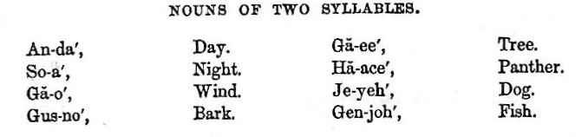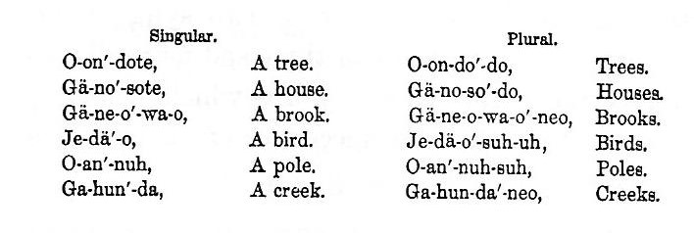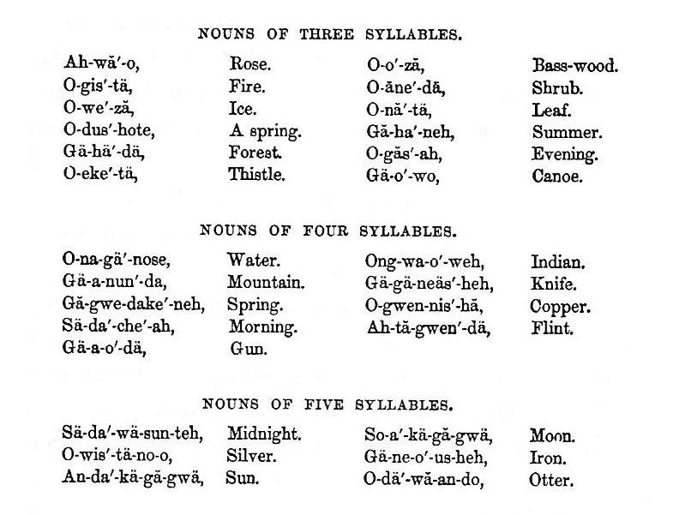

In most, if not all languages, the idea of singular and plural is conveyed by an inflection of the word itself, or by some addition. To illustrate from the language under consideration, which forms the plural in several ways by inflection, the subjoined examples are introduced.

There are several other terminations by which the plural is indicated.

It is said that the dual number originated in the difficulty of inventing the numerals, one, two, three, &c., which are in themselves extremely abstract conceptions. The ideas of one, two and more, which correspond with singular, dual and plural, would be far more easily formed in the mind, than the idea of number in general; and the most simple mode of expressing them would be by a variation of the word itself. Hence in the Hebrew and Greek, which are original or un com pounded languages, in the general sense, the dual is found to exist, while in the Latin, and in modern languages, which are compounds, and were formed subsequent to the invention of numerals, the dual number is discarded. The Iroquois, so far as we know, is an original and uncompounded language, and it has the dual number, both in its verbs and nouns.

Gender was very happily indicated in the Latin and Greek by final letters or terminations. In the English, by giving up the ancient declensions, this mode of designating gender was also laid aside, and two or three modes substituted; thus, that of varying the word itself, as tiger, tigress, of giving the same animal names entirely different, as buck and doe, and more frequently still that of prefixing words which signify male and female. The Iroquois nouns have three genders, which are indicated in the manner last mentioned. Unlike the provisions of other languages, all inanimate objects, without distinction, were placed in the neuter gender.

In some respects the adjective would be a simple part of speech to invent, as quality is an object of external sense, and is always in concrete with the subject. But to discover and adopt a classification, founded upon the similitudes of objects, would be more difficult, since both generalisation and abstraction would be required. The dialects of the Ho-de’-no-sau-nee appear to be amply furnished with this part of speech, on which so much of the beauty of a language is known to depend, to express nearly every shade of quality in objects. Comparison, of which they have the three degrees, is effected by adding another word, and not by an inflection of the word itself, in the following manner: uuu

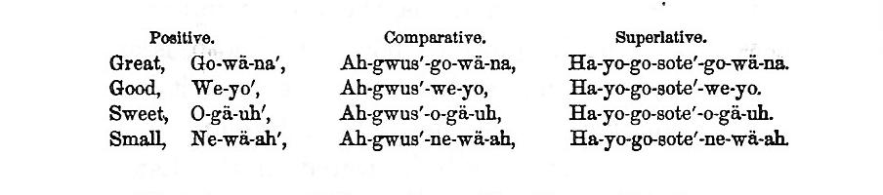

But in connecting the adjective with the noun, the two words usually enter into combination, and lose one or more syllables. This principle, or species of contraction, is carried throughout the language, and to some extent prevents prolixity. The language has but few primitive words, or ultimate roots; and when these are mastered, their presence is readily detected and understood, through all the elaborate and intricate combinations in which they are used. To illustrate the manner of compounding the adjective with the substantive, the following examples may be taken: O-yä’, fruit; O-gä-uh’, sweet; O-yä’-gä-uh, sweet fruit; O, the first syllable of sweet, being dropped. Again, E-yose, a blanket; Gä-geh-ant, white; Yose-ä-geh-ant, white blanket; Gä-no’-sote, a house; We-yo’, good; Gä-no’-se-yo, a good house; literally fruit sweet, blanket white, and house good, illustrative of that natural impulse in man which leads him to place the object before the quality. In other instances the adjective is divided, and one part prefixed and the other suffixed to the noun thus: Ga-nun-dä-yeh, a village; Ne-wä’-ah, small; Ne-gä-nun-dä’-ah, a small village; Ah-tä’-quä-o-weh, a moccason; Ne-wä-tä-quä-ah, a small moccason. The adjective is also frequently used uncompounded with the noun, as Ga-nä’-dike-ho E-yose, a green blanket.

The indefinite article, a or an, is entirely unknown in the language of the Iroquois. There are numerous particles, as in the Greek, which, without significance in themselves separately, are employed for euphony, and to connect other words. These particles qualify and sometimes limit the signification of words; but yet if they should be submitted to a critical examination, none of them would answer the idea of the article a, or an. The existence in completeness of this refined part of speech would indicate a greater maturity and finish than the dialects of the Iroquois possessed. But the definite article na, the, is found in the language. It is not as distinctly defined, and perfectly used, as in more polished languages, but it is usually prefixed to substantives, as with us, to indicate the thing intended.

Of the adverb nothing need be introduced, except to remark that the language is furnished with the usual variety. A few specimens may be added, Nake-ho’, here; O-nä’, now; Ta-dä’, yesterday; Skä-no’, well.

The preposition is allowed to be so abstract and metaphysical in its nature, that it would be one of the last and most difficult parts of speech to invent. It expresses relation " considered in concrete with the correlative object; " and is of necessity very abstruse. The prepositions, of, to, and for, are regarded as the most abstract, from the character of the relations which they indicate. Declension, it is supposed, was resorted to by the Greeks, and adopted by the Latins, to evade the necessity of inventing these prepositions; as it would be much easier to express the idea by the variation of the noun, than to ascertain some word which would convey such an abstract relation as that indicated by of or to. By the ancient cases, this difficulty was surmounted, and the preposition was blended with the correlative object, as in Sermonis, of a speech; Sermoni, to a speech. Modern languages have laid aside the ancient cases, for the reason, it is said, that the invention of prepositions rendered them unnecessary. In the Iroquois language, the prepositions above mentioned are not to be found; neither have its nouns a declension, like the Greek and Latin. Some traces of a declension are discoverable; but the cases are too imperfect to be compared with those of the ancient languages, or to answer fully the ends of the prepositions. This part of speech is the most imperfectly developed of any in the language; and the contrivances resorted to, to express such of these relations as were of absolute necessity, are too complex to be easily understood.

The language, however, contains the simple prepositions, as Da-ga’-o, across; No’-gä, after; Na’-ho, at; O’-an-do, before; Dose-gă’-o, near, &c. It must be inferred that the framers of the language had no distinct idea of the relations conveyed by the deficient prepositions, otherwise they would be found in the language. From the number of particles employed in the language, and the complexity of their combinations, it would be impossible to analyze the word, or phrase, for example, in which on occurs, and take out the specific fragment which has the force of the preposition.

In the imperfect declensions through which the Iroquois substantives are passed, pronouns, as well as prepositions, are interwoven by inflection. These declensions are not reduceable to regular forms, but admit of great diversities, thus rendering the language itself, like all simple and original languages, exceedingly intricate in its inflections. The following examples will exhibit the ordinary variations of the noun.

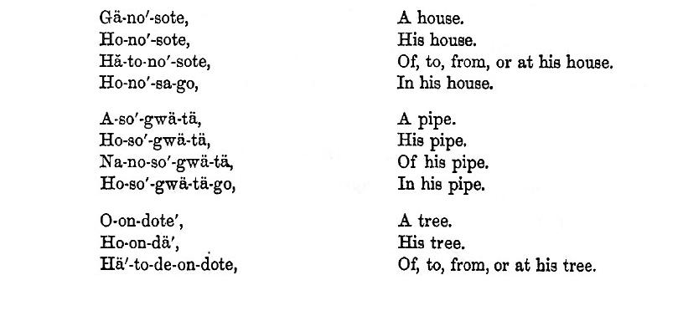

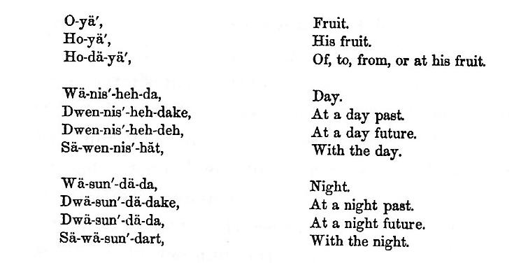

Of the pronouns but little need be added, except that they are very defective: thus E signifies I, we, me, and us; Ese, thou, ye or you, and thee. He and they are wanting, except as expressed in the verb by its inflection. The personal pronouns make the possessive case very regularly, thus: Ah-gä-weh’, mine; Sä-weh’, thine; Ho-weh’, his; Go-weh’, hers; Ung-gwä-weh’. ours; Swä-weh’, yours; Ho-nau-weh’, theirs. Similar variations can be made on some of the relative pronouns.

Interjections are extremely numerous in this language, and appear to be adapted to all the passions. It has also the ordinary conjunctions.

Next and last the verb presents itself. This part of speech, in the nature of things, must have been one of the first invented, as without its aid, there could be no affirmation, no expression of action or passion. Among primitive languages, the conjugation of the verb is extremely complex. Grammarians assign as a reason, that the tenses and moods of the verb would be more easily indicated by its inflection, than by contriving or inventing the substantive verb, I am; the possessive verb, I have; and the auxiliaries, do, will, would, shall, can, and may; all of which are necessary in the conjugation of an English verb. It will be remembered that the English verb admits of but three variations in itself, as press, pressed, pressing; and its conjugation is completed by the auxiliary verbs above-mentioned; while the Greek, Latin, and Iroquois verbs are conjugated, except some part of the passive voice in Latin, by the variations throughout of the verb itself; thus, Legeram, I had read; Che-wä-ge-yä-go, I had shot; Legero, I shall have read; A-wä-ge-yä-go, I shall have shot. In this manner, the conjugation not only dispensed with the pronouns I, thou, and he, with their plurals, but also with the auxiliary verbs, which have introduced such prolixity into modern languages. The Iroquois verbs are conjugated with great regularity and precision, making the active and passive voices, all the moods, except the infinitive, and all the tenses, numbers, and persons, common to the English verb. Some part of the optative mood can also be made.

But the participles are wanting. It is difficult to determine upon what principle the absence of this part of speech, which in a written language would be a serious blemish, shall be accounted for; and much more difficult to ascertain the nature of the substitute in a verbal language. A substitute for the infinitive mood is found in the present tense of the subjunctive mood, together with a pronoun, as in the following passage: " Direct that He’-no may come and give us rain;" instead of saying, “Direct He’-no to come, and give us rain." In correctly translated Indian speeches this form of expression will frequently appear, from the influence which this idiomatic peculiarity of all Indian languages will exercise upon the translator. The origin of the dual number has been adverted to. In the active voice of Iroquois verbs, the dual number is well distinguished; but in the passive voice, the dual and the plural are the same. The presence of this number is indicative of the intricate nature of their conjugations.

To convey a distinct notion of the mutations through which an Iroquois verb passes in its conjugation, and to furnish those who are curious, as linguists, with a specimen for comparison with the conjugations of other languages, one of their verbs, with its inflections, is subjoined in [an appendix]. Its great regularity, even harmony of inflection, conveys a favorable impression of the structure of the language; but it does not, nor would it be expected to possess the elegance and beauty of the Greek, or the brevity and solidity of the Latin conjugations. The principal parts of a few verbs are given as specimens.

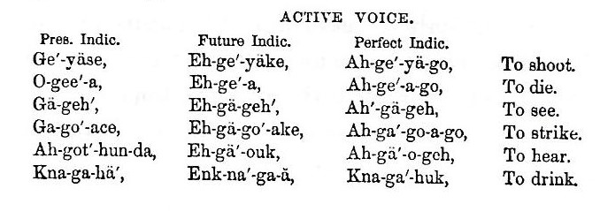

It has been laid down as a maxim, that “the more simple any language is in its composition, the more complex it must be in its declensions and conjugations, and on the contrary, the more simple it is in its declensions and conjugations, the more complex it must be in its composition." The position is thus illustrated: when two people, by uniting or otherwise, blend their languages, the union always simplifies the structure of the resulting language, while it introduces a greater complexity into its materials. The Greek, which is uncompounded, and is said to have but three hundred primitives, is extremely intricate in its conjugations. On the other hand, the Latin, which is a compound language, laid aside the middle voice and the optative mood, which are peculiar to the Greek, and also the dual number. This simplified its conjugations. In its declensions, the Latin, although it has an additional case in the ablative, is yet much more simple than the Greek, as it has no contract nouns. The English, which is a mixture of several languages, is more simple than either in its declensions, which are made by the aid of prepositions alone; and in its conjugations, which are made by other verbs. With this principle in mind, the regularity, fulness, and intricacy of the Iroquois conjugations are not particularly remarkable. Its primitive words, as before remarked, are few, and the language has been formed out of them by a complex and elaborate system of combinations.

The language of the Ho-de’-no-sau-nee has the substantive or neuter verb, E-neh’-ga, I am, although imperfect in some of its tenses. This verb is regarded by philologists as extremely difficult of invention, as it simply expresses being. Impersonal verbs are also very numerous in the language, as O-geon’-de-o, it snows; O-nä-ose’-don-de-o, it hails; Gä-wä’-no-däs, it thunders. It is supposed by those who have inquired into the formation of language, that most of the verbs in primitive tongues originally took the impersonal form, for the reason that such a verb expresses in itself an entire event, while the division of the event into subject and attribute, involves some nice metaphysical distinctions.

Before closing upon this subject it will be proper to notice a few of the peculiarities of the language. In the first place it has no labials, consequently the Iroquois, in speaking, never touch their lips together. This fact may be employed as a test in the pronunciation of their words and names. Their language possesses the numerals firstly, secondly, thirdly, &c., also the numbers one, two, three, ascending, by various contrivances, to about one hundred. For sums above this, their mode of enumeration was defective, as mathematical computation ceased, and some descriptive term was substituted in its place.

The voices of the Ho-de’-no-sau-nee are powerful, and capable of reaching a high shrill key. In conversation its natural pitch is above the English voice, especially with the female, whose voice, by a natural transition, frequently rises in conversation an octave above its ordinary pitch, and sounds upon a tone to which the English voice could not be elevated and retain a distinct articulation. It also passes up and down, at intervals, from octave to octave, the voice retaining upon the elevated key a clear and musical intonation.

In verbal languages the words appear to be literally strung together in a chain, if the one under inspection may be taken as a specimen. Substantives are mingled by declension with pronouns, and sometimes with the substantive verb, or compounded with the adjective, thus forming a new word. Particles are then conjoined, varying or adding to the signification of the compound, until the word, by the addition of the verb, becomes so far extended as to embrace a perfect sentence. The principles upon which these combinations are effected are too much involved to be systematized or generalized. The most which can be said is, that the general result is accomplished by conjugations and declensions, which, although regular in general, are diversified and intricate. To illustrate the manner in which words are made up, the following example may be given. Nun-da-wä-o, the radix of the name of the Senecas, signifies " a great hill; " by suffixing o-no, which conveys the idea of " people at," Nun-da-wä’-o-no, results literally, " the people at the great hill." Next, by adding the particle ga, itself without significance, but when conjoined, conveying the idea of " place " or " territory," it gives the compound Nun-da-wä-o-no-ga’, "the territory of the people at the great hill." A more perfect specimen of the language, as a whole, may be found in the following version of the Lord s Prayer in the Seneca dialect.

G-wä-nee’ gä-o-yä’-geh che-de-oh’; sä-sa-no-do’-geh-teek; gä-o’ ne-dwa na’ sa-nunk-tä; na-huk’ ne-yä-weh,’ na yo-an’-jä-geh ha’-ne-sä-ne-go’-dă ha ne-de-o’-dă na’ gă-o-yä-geh. Dun-dä-gwä-e’-wä-sä-gwus na’ ong-wi-wä-na-ark-seh’ na’ da-yä’-ke-wä-să-gwä-seh na’ onk-ke-wa-na’-ä-ge. Dä-ge-o’-na-geh’-wen-nis’-heh-da na’ ong-wä-quä’ Să-nuk na-huh’ heh’-squä-ä ha’ gä-yeh na’ wä-ate-keh’ na-gwä na’ dä-gwä-yä-duh’-nuh-onk ha’ gä-yeh na’ wä-ate-keh’; na’ seh-eh’ na ese’ sä-wä na’ o-nuk-ta’ kuh’ na ga-hus-ta-seh kuk na’ da-gä-ă-sä-uh’. Na-huh’-ne-yä-weh.

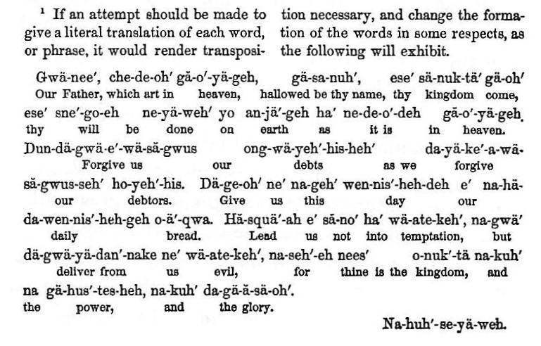

Names of places as well as of persons, form an integral part of their language, and hence are all significant. It furnishes a singular test of their migrations, for accurate descriptions of localities become in this manner incorporated into their dialects. The Tuscaroras still adduce proof from this source to establish a common origin with the Iroquois, and pretend to trace their route from Montreal, Do-te-ä-co, to the Mississippi, O-nau-we-yo’-kä, and from thence to North Carolina, out of which they were driven in 1712. The era of their separation from the parent stock, and of this migration, they have entirely lost; but they consider the names of places on this extended route, now incorporated in their language, a not less certain indication of a common origin than the similarity of their languages. Indian languages are exceedingly tenacious of traditionary facts intrusted to their preservation.

