‘Whom Shall I Fear?’ In South Texas, Two Bakers Face Trump’s Immigration Wrath.

A raid on Abby’s Bakery in Los Fresnos heralded the crackdown to come. Ahead of the owners’ trial for “harboring” undocumented workers, the community is seeing the impact of the president’s policies.

By Edgar Sandoval

Reporting from Los Fresnos, Texas

The New York Times

May 17, 2025

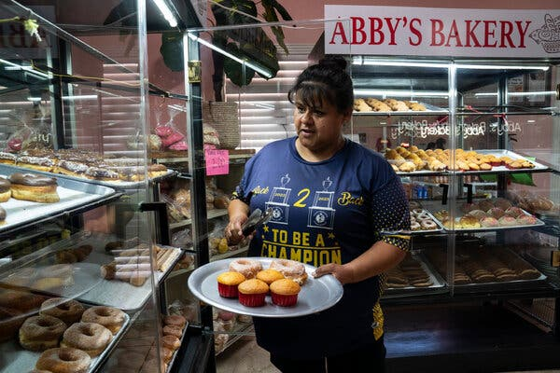

Jessica Castro selected treats from a case at Abby’s Bakery in Los Fresnos, Texas. “They need us,” she said of the business.

Most mornings, Leonardo Baez, a father of seven, wakes up hours before sunrise to mix bread dough in the border city of Los Fresnos, Texas. Punishing and laborious work, yes, but owning a beloved bakery has been a lifelong dream of his, he said.

It is now in jeopardy.

In February, federal agents swooped down on his shop, Abby’s Bakery, detained workers they said were in the country illegally and pressed charges against the owners, Mr. Baez and his wife, Nora Alicia Avila.

As their July trial nears, many in this Latino-majority community of 8,500 close to Brownsville, Texas, are learning what life will be like under President Trump and his immigration crackdown. More than 52 percent of Los Fresnos’s once-bright-blue Cameron County voted for Mr. Trump in November, but his aggressive policies are dividing families and rattling local business where undocumented residents are indistinguishable from the larger border population.

If found guilty of the most serious charge, conspiring to transport and harbor undocumented migrants, both Mr. Baez, 56, and Ms. Avila, 46, face sentences of up to 10 years in prison.

The Justice Department has framed the case as open-and-shut: Law enforcement officers found a room in the shopping plaza that includes the bakery with six mattresses on the floor housing employees unauthorized to work in the country. The raid, the government said, found two migrants “unlawfully present in the United States” and six visa holders “who did not have the right to work.”

The Baez family agreed to discuss their lives, but at the suggestion of their lawyers, they would not talk about the case. But one of those lawyers, Jaime Diez, did speak on the case and said the federal indictment is a break from how “harboring” charges are typically used.

“Harboring charges used to be saved for cases where criminal groups would help smuggle undocumented people into the U.S. illegally,” he said. Migrants would “then be stashed in houses until they could be picked in cars where they would be hidden so that they could be taken up north,” he added.

A recent wave of high-profile immigration actions, such as visits this month to Washington, D.C., restaurants owned by the celebrity chef Peter Chang and the husband of the CBS News correspondent Norah O’Donnell, may have left the impression that the reach of Immigration and Customs Enforcement is long and targeted at liberal urban redoubts and establishments that grab headlines.

But in Los Fresnos, the arrests of Mr. Baez and Ms. Avila — immigrants of Mexico who are pillars of the community and decidedly not celebrities — feel personal, local residents said. Mr. Chang and Geoff Tracy, Ms. O’Donnell’s husband, were not arrested, nor were any of their employees detained. Mr. Baez and Ms. Avila face potential prison terms, loss of their legal status and deportation if they are found guilty of harboring illegal immigrants.

“What we are witnessing is the federal government targeting smaller minority-owned businesses, which aligns with the current administration’s views on immigrants and immigration,” said Sylvia Gonzalez-Gorman, a professor at the University of Texas Rio Grande Valley who specializes in immigration.

Angela Dodge, a spokeswoman for the U.S. attorney’s office in the Southern District of Texas, said each case is prosecuted on its merit.

“We consider each such case based on the evidence and what can be proven beyond a reasonable doubt in a court of law,” Ms. Dodge said.

On Feb. 12, as Mr. Trump’s second term got underway, a team from Homeland Security Investigations conducted what it described as a work-site enforcement action at Abby’s Bakery next to a busy road.

Videos posted on Facebook showed armed officers escorting despondent handcuffed workers out of the property. A woman recording the video can be heard saying: “They took all of the workers here, Abby’s. Look how they take them.”

A criminal complaint said agents found eight undocumented workers, whom court documents paint as knowingly hired and sheltered by the couple.

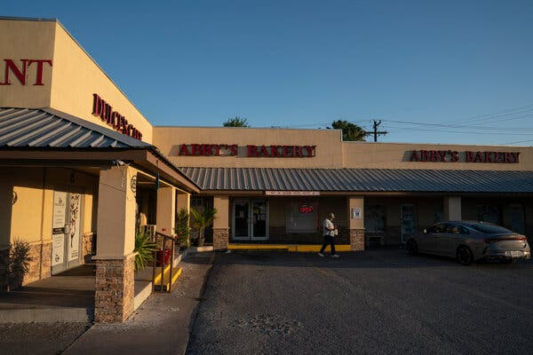
Immigration raids have rattled local shops, tortillerias and used clothing shops along the U.S.-Mexico border.

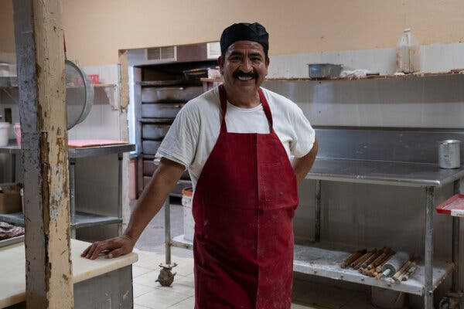
“The community never stopped supporting us,” said Leonardo Baez, one of the owners of Abby’s Bakery.

Mr. Baez and Ms. Avila, legal U.S. residents with green cards who have owned the bakery for nearly 15 years, “admitted they knew the aliens were unlawfully present in the United States in violation of the law, and they harbored aliens in their personally owned property,” according to prosecutors’ court filings.

A week after the raid, the couple reopened the bakery doors with about seven legal workers, including family members. Ms. Avila operates an adjoining restaurant that opened last year, and Mr. Baez said they try to focus on work, not their possible legal peril.

“The community never stopped supporting us,” Mr. Baez said.

As it turned out, the raid on Abby’s was just the beginning. In recent days, the Trump administration has directed about 2,000 agents from the Drug Enforcement Administration; the Bureau of Alcohol, Tobacco, Firearms and Explosives; the U.S. Marshals Service and the F.B.I. to aid ICE agents in finding and arresting undocumented immigrants, a sharp escalation in the administration’s effort to fulfill a campaign promise to enact mass deportations.

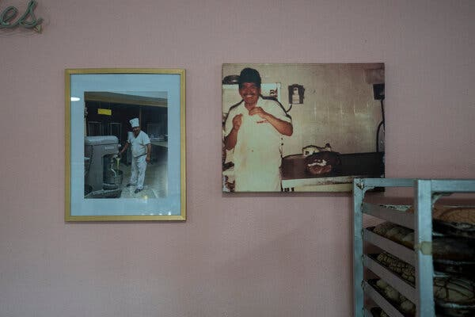

Mr. Baez and his wife have owned Abby’s Bakery for nearly 15 years.

Image

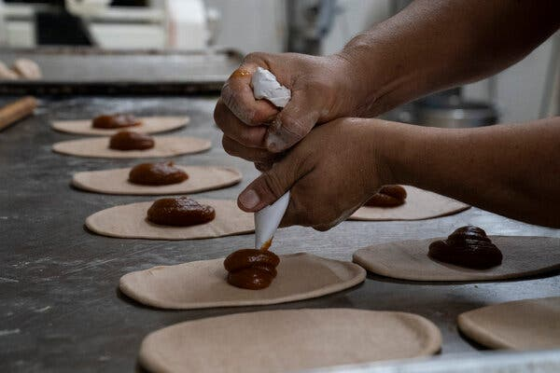
In February, federal agents swooped down on Abby’s Bakery and detained workers they said were in the country illegally.

But in Los Fresnos, that larger picture is less important than the local ordeal at hand. Jessica Castro, 46, earlier this week scanned the freshly baked goods, such as conchas, a pastry in the shape of a seashell, empanadas and Mexican cake, her husband’s favorite. She explained why it was important to buy the Baezes’ bread instead of the supermarket’s.

“They need us,” she said.

The rightward shift in the Rio Grande Valley was driven, in part, by the toll that inflation had taken on a region where the median income has remained stubbornly low, at around $33,000, residents say. Since then, immigration raids have shaken local shops, like tortillerias and used clothing shops, leaving many worried they could be next. Family members with mixed immigration statuses — citizens, green card holders and undocumented migrants — often live and work under one roof.

“As soon as I heard what happened, my heart broke for them,” Ms. Castro said as she loaded a tray with baked goods. “I want them to know that locals are here for them, and we want them to be OK.”

Edward Padron, 67, a longtime Republican and Army veteran who voted for Mr. Trump, scoffed at the sentiment.

“Sympathy has nothing to do with it,” he said. “The law is the law.”

Earlier that day, Mr. Baez marched into his sweltering kitchen and adjusted a red apron, intent on the work before him. One of his sons and a son-in-law watched intently as Mr. Baez placed several pieces of oval-shaped dough on a metal table and loaded them with pumpkin filling with speed and precision.

“We try to keep up with him and learn from what he does,” said Juan Aguilar, his 30-year-old son-in-law, as his eyes followed Mr. Baez’s fast-moving hands.

Mr. Baez said that he was leaving his and his wife’s fate up to God. Symbols of his faith are evident throughout the shop, with religious phrases and pamphlets greeting customers.

He finds solace in Bible passages he has memorized. On this day, while on a break, Mr. Baez cleared sweat from his forehead and recited a verse that speaks to him from Psalm 27.

“The Lord is my light and my salvation — whom shall I fear? The Lord is the stronghold of my life — of whom shall I be afraid?” he said in Spanish.

Mr. Baez said achieving the American dream seemed like an impossible goal growing up in Ciudad Victoria, Tamaulipas, a Mexican state bordering Texas.

He sold bread on the streets, learned how to make it from a mentor and married his wife when she was 18 and he was 28. Soon after, the couple decided to try their luck in the United States.

“I asked her, ‘let’s go work on the other side,’” he recalled.

They moved with his mother-in-law to a small brick home with a metal roof and an outhouse in Los Fresnos, where he made bread and sold it on the streets with his children.

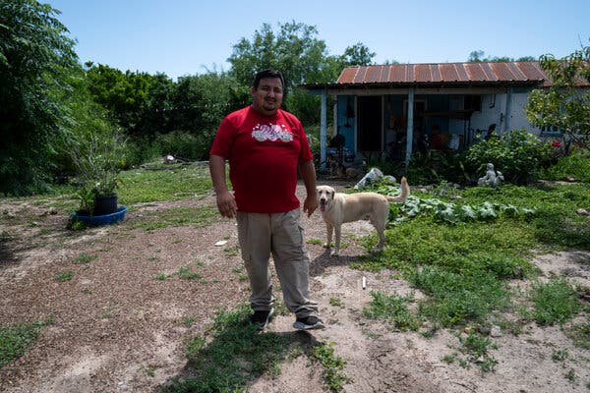
Gabriel Baez, Leonardo Baez’s son, beside his grandmother’s home in Los Fresnos, Texas, where the family used to live when they first arrived to the country.

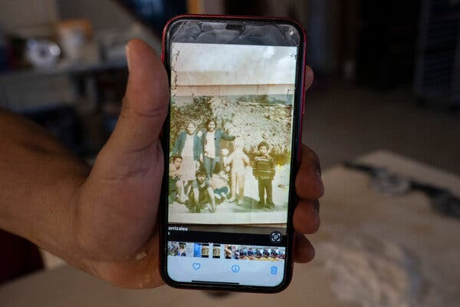
Leonardo Baez, far right, in front of a home where he used to live as a child in Mexico.

Gabriel Baez, 32, one of his sons, said the family truck was so old back then that they had to push it down a dirt road to get it running. He and his brother Josue, 23, recalled being scared at night to use the outhouse, where alligators and snakes were known to crawl up from a nearby creek.

“You had to be on the lookout,” Josue said with a chuckle.

A few years later, the Baezes bought a wooden home with a working bathroom. In 2011, Mr. Baez stopped by a mechanic and saw that the building next door was up for rent. He borrowed money from members of his church and purchased basic bread making equipment to start his bakery.

“From the moment we opened, the customers never stopped coming,” Mr. Baez said. “God has blessed us that way.”

The business has expanded since. Today, the Baezes own the entire shopping center that includes the bakery, the size of half a block. Mr. Baez wants his legacy to live on for his growing family, which includes seven children, five in the United States, and 14 grandchildren, with two more on the way.

Whatever happens after the trial in July, he said, the dream that became Abby’s Bakery will live on through them.

“All of this is for my family,” he said.

Gabriel V. Cárdenas contributed reporting.

