Aileen Ward, Author of Award-Winning Keats Biography, Dies at 97

By William Grimes

The New York Times

June 7, 2016

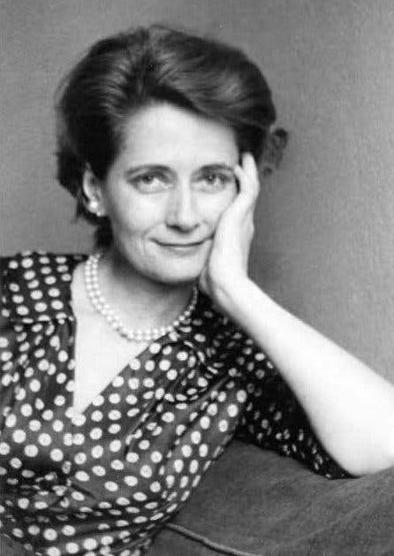

Aileen Ward in an undated photograph.

Aileen Ward, a scholar whose sympathetic, insightful biography of the Romantic poet John Keats won a National Book Award in 1964, died on May 31 in her home in Santa Monica, Calif. She was 97.

The death was confirmed by her nephew Alex Ward.

Professor Ward spent nine years researching “John Keats: The Making of a Poet,” the first major account of his life since the publication of Amy Lowell’s two-volume “Keats” in 1925. Her aim was twofold: to critically analyze Keats’s poetry and, by reading his inner life, to explain what she called his “audacious act of self-creation.”

In conferring the prize, the administrators of the National Book Award praised the biography as a “searching and perceptive reappraisal of a major literary figure,” calling it an “honest, moving, and beautifully balanced work — a truly distinguished portrait.”

As is happened, Professor Ward prevailed over a mighty rival, the Harvard literary historian Walter Jackson Bate, who came out with his own Keats biography a few months after Professor Ward’s, to admiring reviews and, eventually, a Pulitzer Prize. It, too, was in the running for the National Book Award — seemingly a David-and-Goliath contest in terms of the authors’ reputations — but the readability and psychological acumen of Professor Ward’s version won the day.

“The question Bate leaves unexplained is what made the man become the poet,” Philip C. Rule wrote in “Seeing Into the Life of Things: Essays on Religion and Literature” (1997), edited by John L. Mahoney. “This is precisely the question that Aileen Ward sets out to answer.”

Professor Ward was doubly honored when she won the Duff Cooper Memorial Prize in Britain for her biography. She was both the first American and the first woman to win that prize.

“As Allen Tate was the first to say, Keats is one of the real heroes of literature,” she said when receiving the National Book Award. “There is hardly another life we know of that speaks so eloquently of the daring, the energy and dedication that are required for great achievement as a writer.”

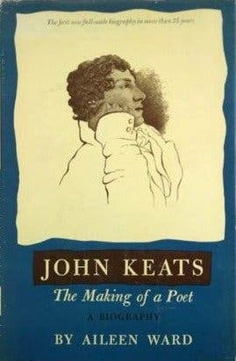

The cover of “John Keats: The Making of a Poet.”

Aileen Coursen Ward was born on April 1, 1919, in Newark and grew up in Summit, N.J. Her father, Waldron, was a lawyer; her mother was the former Aline Coursen.

After earning a B.A. in English from Smith College in 1940, she enrolled in Radcliffe, where she was awarded an M.A. in 1942 and a doctoral degree in 1953, with a dissertation on poetic metaphor.

Professor Ward taught at Wellesley and Barnard before joining the Vassar English department in 1954. She later taught at Sarah Lawrence, Brandeis and New York University. She retired in 1990.

While at Wellesley, she struck up a friendship with Vladimir Nabokov, who was teaching Russian there. To cope with wartime gasoline rationing, the college organized car pools for commuters, and she and Nabokov shared a car that took them to their homes in Cambridge.

In an interview with Brian Boyd, the author of “Vladimir Nabokov: The American Years,” Professor Ward recalled that she and Nabokov would pass the time by making up parodies of poems by Thomas Hardy, A. E. Housman and other poets.

When Nabokov was trying to find someone to replace him when he left Cornell, shortly after the publication of “Lolita,” it was she who came up with a successful recommendation, the novelist Herbert Gold.

Professor Ward wrote introductions to editions of William Blake and Thomas De Quincey and edited a collection of Keats’s poems. She served for many years on the board of Yaddo, the writers’ retreat in Saratoga Springs, N.Y.

She leaves no immediate survivors. Her longtime partner, Nancy Cardozo, died in 2014.

At her death, Professor Ward had been at work for a half-century on a biography of Blake. “The commitment is like climbing up to the top of a high diving board,” she told Booklist in 2003. “There is only one way to get down again that you can contemplate.”

