War

"A real Komi man, the pride of the people." Why philosopher Nikolai Zyuzev was arrested
October 05, 2025
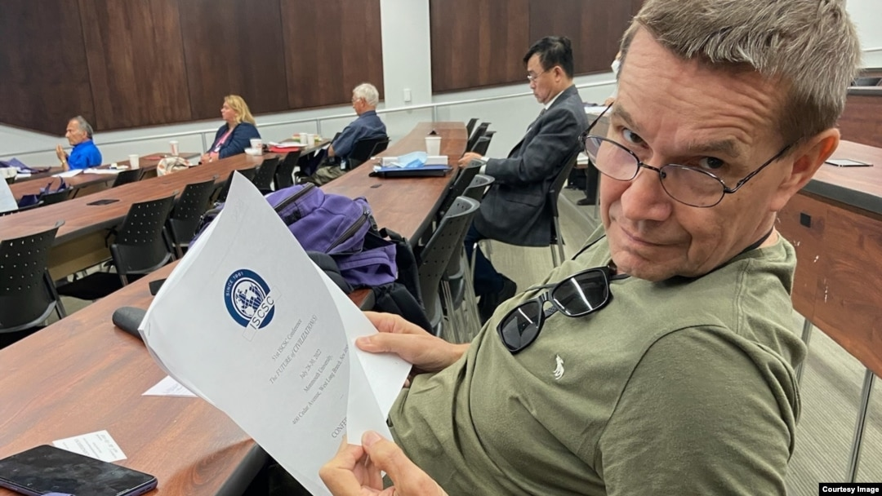
Philosopher Nikolai Zyuzev, 2022, photo from his personal Facebook page
"He is a man of sharp mind and excellent human qualities, for me personally he is an ideal professor whom I have always wanted to look up to," says the former teacher of Syktyvkar State University, who for many years has known 69-year-old Nikolai Zyuzev, who was arrested for "cooperation on a confidential basis with a foreign state, international or foreign organization" (Article 275.1 of the Criminal Code of the Russian Federation).
Philosopher Nikolai Zyuzev, a former professor at Syktyvkar State University, is one of the most famous researchers of the legacy of Pitirim Sorokin, a Russian and American sociologist and culturologist, educator, one of the founders of the theories of social stratification and social mobility, who was also born and lived in Komi. Zyuzev wrote two books about Sorokin.
In 2008, he moved to Toronto, where he became a Canadian citizen. In 2016, he returned to Russia and taught at Syktyvkar State University until 2022. After the start of the Russian invasion of Ukraine, the scientist again left for Canada, but sometimes returned to his native village in the Kortkeros district.

"He can't do without his village and fishing"
Nikolai Zyuzev was arrested at the end of June, but this became known only a few days ago, when his friends on the website of the Supreme Court of Komi saw information about the extension of his measure of restraint - detention. Journalists of the Komi Daily wrote about the arrest of the famous scientist .
"Nikolai Fedoseevich and I were in touch all the time, called and corresponded," says his good friend. "And suddenly he did not answer one letter, to another, he simply disappeared altogether. I called other mutual friends - they also do not know anything. But in general, Zyuzev is a real Komi man, he cannot live without his village, where he grew up, and without fishing, he always goes there in the summer. We thought he was there and maybe something with the connection. Or went fishing for a long time. And it turned out that he was arrested.
In the criminal case of the philosopher Zyuzev, so far there are only one questions. "You see, it's scary to do harm: he is no longer young, the article is serious, I feel sorry for any young person who is accused of such a thing and imprisoned, but for Nikolai Fedoseevich it will be ten years," explains a close acquaintance of Zyuzev.
Nikolay was born in the small village of Podelsk in the Kortkeros district of the Komi Republic, about 100 kilometers from Syktyvkar. His mother was the director of an orphanage, most of the children there were Russians. "My mother raised me and my brother alone, we spent almost all the time in an orphanage with these children. Therefore, I have two native languages: Komi and Russian," Zyuzev said in an interview.
Then he graduated from the Faculty of Philology of Syktyvkar State University. He received his philosophical education at the graduate school of the Faculty of Philosophy of Lomonosov Moscow State University. He taught at the Komi State Pedagogical Institute (1995–2011), Syktyvkar State University (2010–2011), and headed the Department of Philosophy at Ukhta State University (2006–2009). In 2005–2006, he completed an internship at Harvard University (USA) as a professor. At Harvard, he collected material for his next book about Pitirim Sorokin, "Pitirim Sorokin's Rollercoaster", who spent most of his life at Harvard, where he founded the Department of Sociology. In 2013, Zyuzev received a law degree from Everest College (Toronto, Canada). From 2012 to 2015, he taught at Massey College (University of Toronto, Canada). In 2015, he received Canadian citizenship.
In the same 2015, he returned to Syktyvkar, where he was offered to head a new research center at the local State University named after Pitirim Sorokin. "How could I refuse? My marriage fell apart, and I could not break into the tough Canadian academic market," Zyuzev recalled. — Despite my misgivings about what was happening in Russia, I couldn't miss the chance to return to teaching and revitalize my academic career. The purpose of the center was to develop ties with scientists from Europe, North America and other regions."
"Nikolay Fedoseevich is my favorite teacher, his lectures are a real feast of the spirit, thanks to him I fell in love with science and decided to continue doing it," says one of his former students now.
The war in Ukraine put an end to the careers of many Russian scientists who did not support the aggression. In 2022, according to the Scopus bibliographic and citation database , 1,465 scientists left Russia, and 1,938 in 2023, while the influx amounted to 672 and 618, respectively (a net minus of about 0.8% of active researchers per year). that the country has lost 50 thousand researchers over the past five years.
"With someone, like me, the contract was simply not renewed, someone was terminated, someone resigned, realizing that it would be difficult to remain silent on the topic of war, and it was simply dangerous to talk," recalls one of the teachers of Syktyvkar State University, who left Russia. "Nikolai Fedoseevich, who also opposed the war and left for Canada, was an outstanding specialist and teacher, his loss for science and the university is very significant.
Nikolai Zyuzev was the pride of the republic, says another of his acquaintances.
Nikolay Zyuzev, photo from his personal Facebook page
— Few people can boast of such a biography as his: a simple rural guy made his way into the world himself, worked in prestigious world universities, he is one of the largest researchers of Pitirim Sorokin, he was invited to all significant world events on this topic. In the 1990s, Zyuzev was a well-known journalist in the republic, interviewed top officials, he speaks the Komi language perfectly. It is impossible to believe that he allegedly worked anonymously for another state - everyone knew about Canada and about his work, he was always open to communication.

A piece of paper is enough
Article 275.1 of the Criminal Code of the Russian Federation - "Cooperation on a confidential basis with a foreign state, international or foreign organization" - appeared in 2022 after the start of the war in Ukraine, it provides for up to 8 years in prison. To get a sentence for "secret cooperation", it is enough to correspond with a representative of the state / organization in order to "harm the security of the Russian Federation", say lawyers of the First Department, who defend many defendants in cases of treason and others related to state security.
"As a rule, it says that the phone number or the subscriber himself is a representative of a foreign special service or act against the security of the Russian Federation," explains a lawyer working on such cases, who asked not to indicate his name. to send a person to places not so remote. And if in 2023, according to the Supreme Court, only two sentences were issued under this article , now the count is in the tens and hundreds per year. There was not a single acquittal.
According to the "First Department" (as of mid-December 2024), in Russia, after the start of the full-scale invasion of Ukraine, 792 people became defendants in criminal cases of treason (Article 275 of the Criminal Code of the Russian Federation), espionage (Article 276 of the Criminal Code of the Russian Federation) and confidential cooperation with a foreign state (Article 275.1 of the Criminal Code of the Russian Federation). In 2024, 359 people received real terms, four were assigned compulsory treatment. Of the 359 people, 224 were found guilty under Article 275, 38 under Article 275.1 and 101 people under Article 276. There were no acquittals.
"The local FSB has the task of compiling a certain database of "unreliable people", they need to report on the articles of how many cases have been initiated. And Zyuzev got into this database, and he was arrested for reporting. In the region, the FSB has an ambitious leadership, someone there is diligently trying to make a career, this is proved by the recent story with the Revolt Center," says an informed interlocutor in Komi.
The Revolt Center was established in 2019 in Syktyvkar as an independent cultural space. It was named after the Soviet mathematician and human rights activist Revolt Ivanovich Pimenov (1931–1990), who was exiled to Komi in 1971 on charges of dissident activities, and then remained in Komi and worked at the local branch of the Academy of Sciences (Pimenov received his name from his father in honor of the Parisian anarcho-communist magazine Le Revolte (The Revolt), published by the anarchist Peter Kropotkin). The center talked about both the Komi culture and the legacy of Pimenov.
The search of Nikolai Zyuzev took place at the end of June 2025, and on July 8, the security forces searched journalists and human rights activists in 12 regions, and the Revolt Center in Syktyvkar became the center of the attack. Searches took place both in the cultural space itself and in the apartments of its employees "Revolt Center" Daria Chernysheva. She was accused of "failing to provide documents for the inclusion of herself in the register of "foreign agents" and was left in custody in a temporary detention center, and then transferred to house arrest.
In a press release issued by the FSB after the searches, it was said that "the executive director of the 7x7 publication, Pavel Andreev, for a long time maintained secret contacts with representatives of NATO countries, as well as organizations used by foreign special services as a cover for conducting intelligence and subversive activities on the territory of Russia. On the instructions of the foreign side, the defendant carried out the implementation of projects aimed at violating the territorial integrity and constitutional order of the Russian Federation." Andreev, according to the FSB, received money from foreigners to destroy Russia. The management of 7x7 stated in turn that the publication has completely distanced itself from the Revolt Center since 2022 and is currently not associated with it in any way.
"We express our support to all victims of this criminal case. We regard it as an attempt to intimidate people for whom love for their homeland and civic responsibility for what is happening around them are not meaningless memorized clichés, but the content and meaning of life," the publication said in its appeal to readers. "Talking about social problems and trying to find solutions, helping people who are unjustly persecuted and tortured is true patriotism."
- Perhaps, within the framework of the Revolt Center case, the FSB needed someone who had contacts with the West personally. And then the arrested Nikolai Zyuzev fits such a task," the interlocutor in Komi argues. "All the other defendants in this case sit quietly, do not go anywhere. Only Pavel Andreev, the ex-director of the Revolt Center and co-founder of 7x7, against whom the regional department of the FSB opened a criminal case of treason in early July, and he and his family went abroad, are on everyone's lips. Everyone who worked abroad is on a separate list, work is underway on them.
"Zyuzev had nothing to do with the Revolt Center team either before or after 2022," says Pavel Andreev. — Maybe I spoke once or twice, like hundreds of other speakers.
Zyuzev, who was apparently in plain sight in the republic, should not have come to Russia, is now worried about his acquaintances - his biography is too bright nowadays and fits a whole heap of recently adopted criminal articles. They hope that as a result of publicity, Canadian diplomats will intervene in his fate and the republican FSB will now not be able to imprison him quietly.
"No matter what is written in his criminal case, none of those who know Zyuzev personally and know what and what he lives for, will ever believe it," his friends say. They are struck by the similarity of the fate of Nikolai Zyuzev and Pitirim Sorokin, whose legacy he has been studying all his life. In 1918, Pitirim Sorokin was arrested by the Cheka and sentenced to death. Only Lenin's personal intervention and Sorokin's public repentance saved his life. 103 years ago, Pitirim Sorokin was deported from the USSR on the so-called "philosophical steamship".
Original publication: Sever.Realii
Subscribe to our Telegram channel.

Idel.Realii © 2025 RFE/RL, Inc. All rights reserved

